WHITE HORSE EXPLORER UNIT
EXPLORER WINTER CAMP 2015
FLATHOLM ISLAND Friday 27th to Sunday 29th March
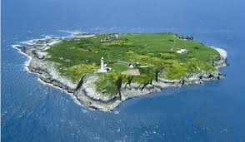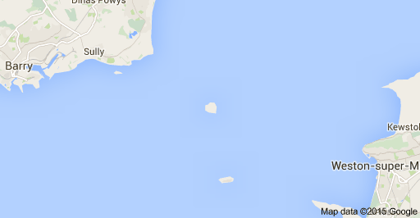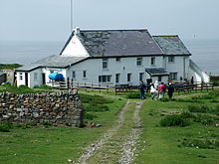

This year’s camp will be on Flatholm Island or in Welsh Ynys Echni, it is located in the middle of the Bristol Channel. On Friday evening we will travel down by mini bus and stay in a youth hostel in Cardiff. On Saturday morning I have hired Rib boats that will take us to Flatholm Island, where we will stay for the Saturday night in bunk rooms at the Old Farmhouse and explore the islands rich environment. We will be collected the on the Sunday afternoon for a rib boat ride back to Cardiff and then travel back to Stanford.
The island has a long history dating from Anglo-Saxon, Viking period and Saint Cadoc used the island in the 6th century. An isolation sanatorium for cholera patients was built in 1896 and the inventor Marconi transmitted the first wireless signals over open sea from Flat Holm. Because of frequent shipwrecks a lighthouse was built on the island and the present one dates from 1737. The islands has a strategic position on the approaches to Bristol and Cardiff and a series of gun emplacements were built in the 1860s and during WWII the island was rearmed, with many of the derelict gun emplacements still remaining.
It is now managed by Cardiff Council and is designated as a Site of Special Scientific Interest and a Special Protection Area. The Island is occasionally visited by day-trippers, but the only full time occupant is the Warden for the Reserve. We are very privileged to get to the island and even more to be able to stay over night.
But all this privilege comes at a price ! I have made costing on 17 Explorers going to camp and the price is about £90-£100. The money includes travel, accommodation and food. This is a very special location for our winter camp and it will be a wonderful adventure.

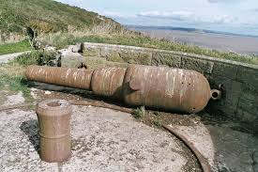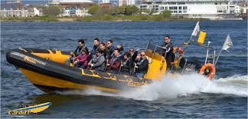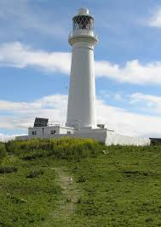
TO CONFIRM A PLACE ON THE CAMP YOU MUST REPLY TO THE SCOUT WEBSITE INVERTATION or email me - faypendell@hotmail.com. Any questions please contact me

